Lab 4 : Real-World Integration: Connecting Cortex to Jira

Introduction
While Large Language Models are incredibly powerful for generating code and reasoning about static data, enterprise workflows are highly dynamic. If a Product Developer asks an AI agent, "What is the status of Jira ticket DEV-123?", a static agent cannot answer.
To bridge this gap, we must integrate Snowflake with external APIs. In this lab, you will configure Snowflake's External Network Access (ENA) to securely communicate with a live Jira environment. You will build a Python User-Defined Function (UDF) that hits the Jira REST API to fetch real-time ticket data. Finally, you will author a custom Cortex Code skill that teaches the agent how to use this UDF, transforming cortex into an active participant in your engineering lifecycle.

Learning Objectives
Upon completing this lab, you will be able to:
- Configure Snowflake Network Rules and Secrets to securely manage API credentials.
- Establish an External Access Integration to permit outbound traffic from Snowflake.
- Create a Python UDF that makes authenticated HTTP GET requests to the Jira REST API.
- Author a cortex skill that instructs the agent to query live external systems.

Prerequisites
Before starting, ensure you have:
- The ACCOUNTADMIN role in your Snowflake environment (required for creating Network Rules and Integrations).
- A Jira Cloud account. If you do not have one, you must sign up for a free Atlassian Jira software trial.
- A Jira API Token. You can generate this from your Atlassian account security settings.
- Your Jira domain name (e.g., your-domain.atlassian.net).

Part 1 — Configuring Secure External Access
Snowflake is highly secure by default and blocks all outbound HTTP network traffic. To allow our UDF to talk to Jira, we must explicitly declare a Network Rule and securely store our authentication credentials.

Step 1 — Create the Network Rule
Execute this SQL in a Snowsight Worksheet. Replace your-domain with your actual Jira trial domain prefix.
USE ROLE ACCOUNTADMIN;
CREATE OR REPLACE DATABASE integrations_db;
CREATE OR REPLACE SCHEMA external_apis;
CREATE OR REPLACE NETWORK RULE jira_network_rule
MODE = EGRESS
TYPE = HOST_PORT
VALUE_LIST = ('your-domain.atlassian.net');

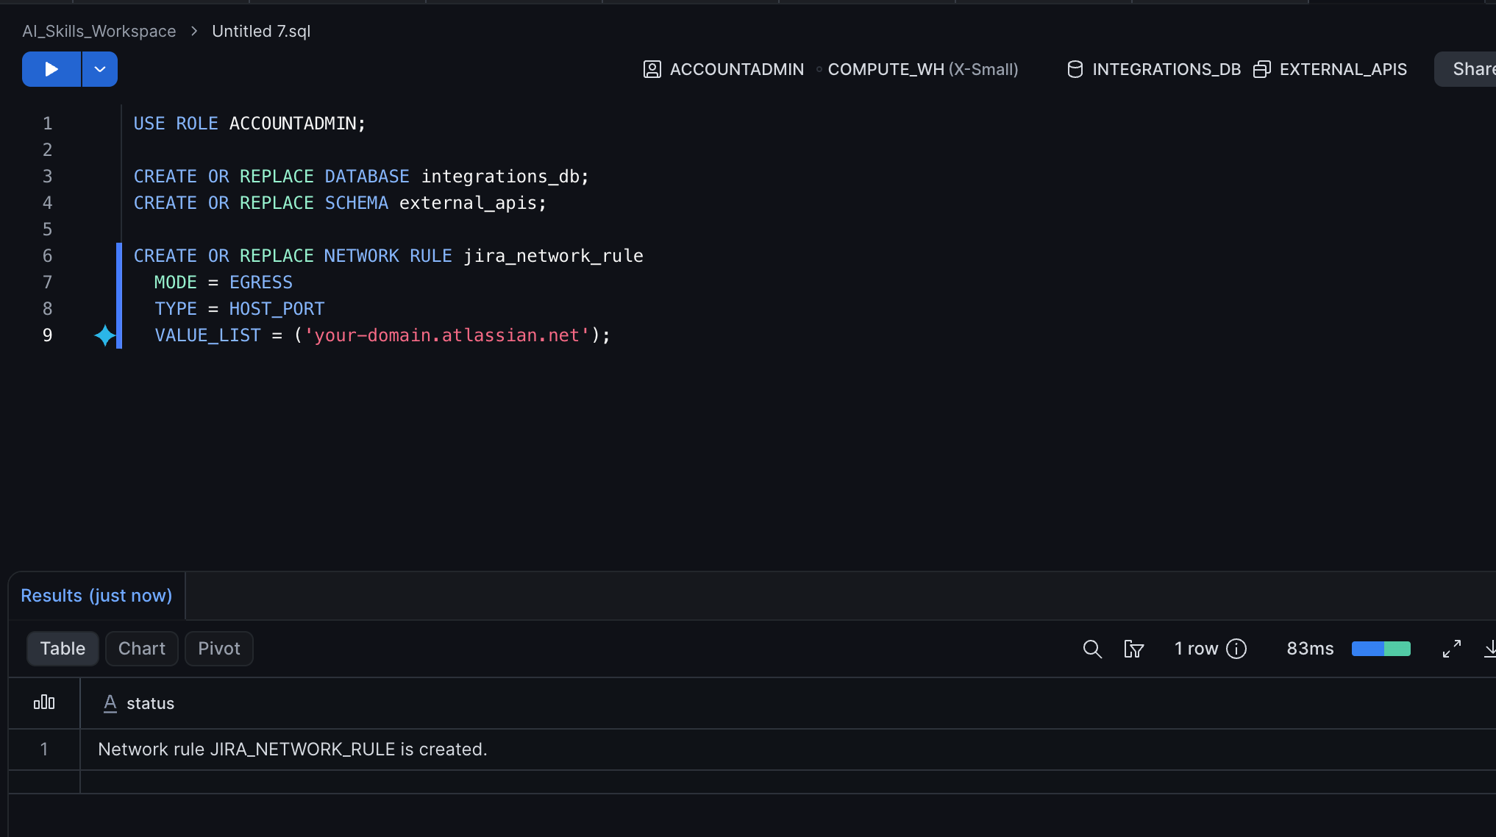

Step 2 — Store API Credentials Securely
We must never hardcode API tokens in our Python scripts. We will use a Snowflake Secret to store the Basic Authentication details (your email and Jira API token). Replace the placeholders with your actual email and token.
CREATE OR REPLACE SECRET jira_api_token
TYPE = PASSWORD
USERNAME = 'your_email@example.com'
PASSWORD = 'YOUR_JIRA_API_TOKEN';

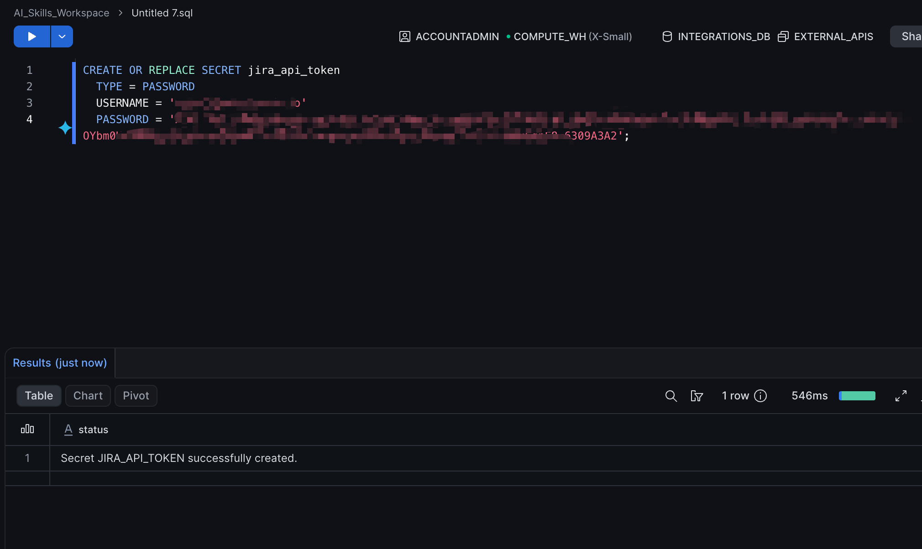
Expected Output:
Secret JIRA_API_TOKEN successfully created.

Step 3 — Create the Integration
Bind the rule and the secret together into an External Access Integration.
CREATE OR REPLACE EXTERNAL ACCESS INTEGRATION jira_integration
ALLOWED_NETWORK_RULES = (jira_network_rule)
ALLOWED_AUTHENTICATION_SECRETS = (jira_api_token)
ENABLED = TRUE;

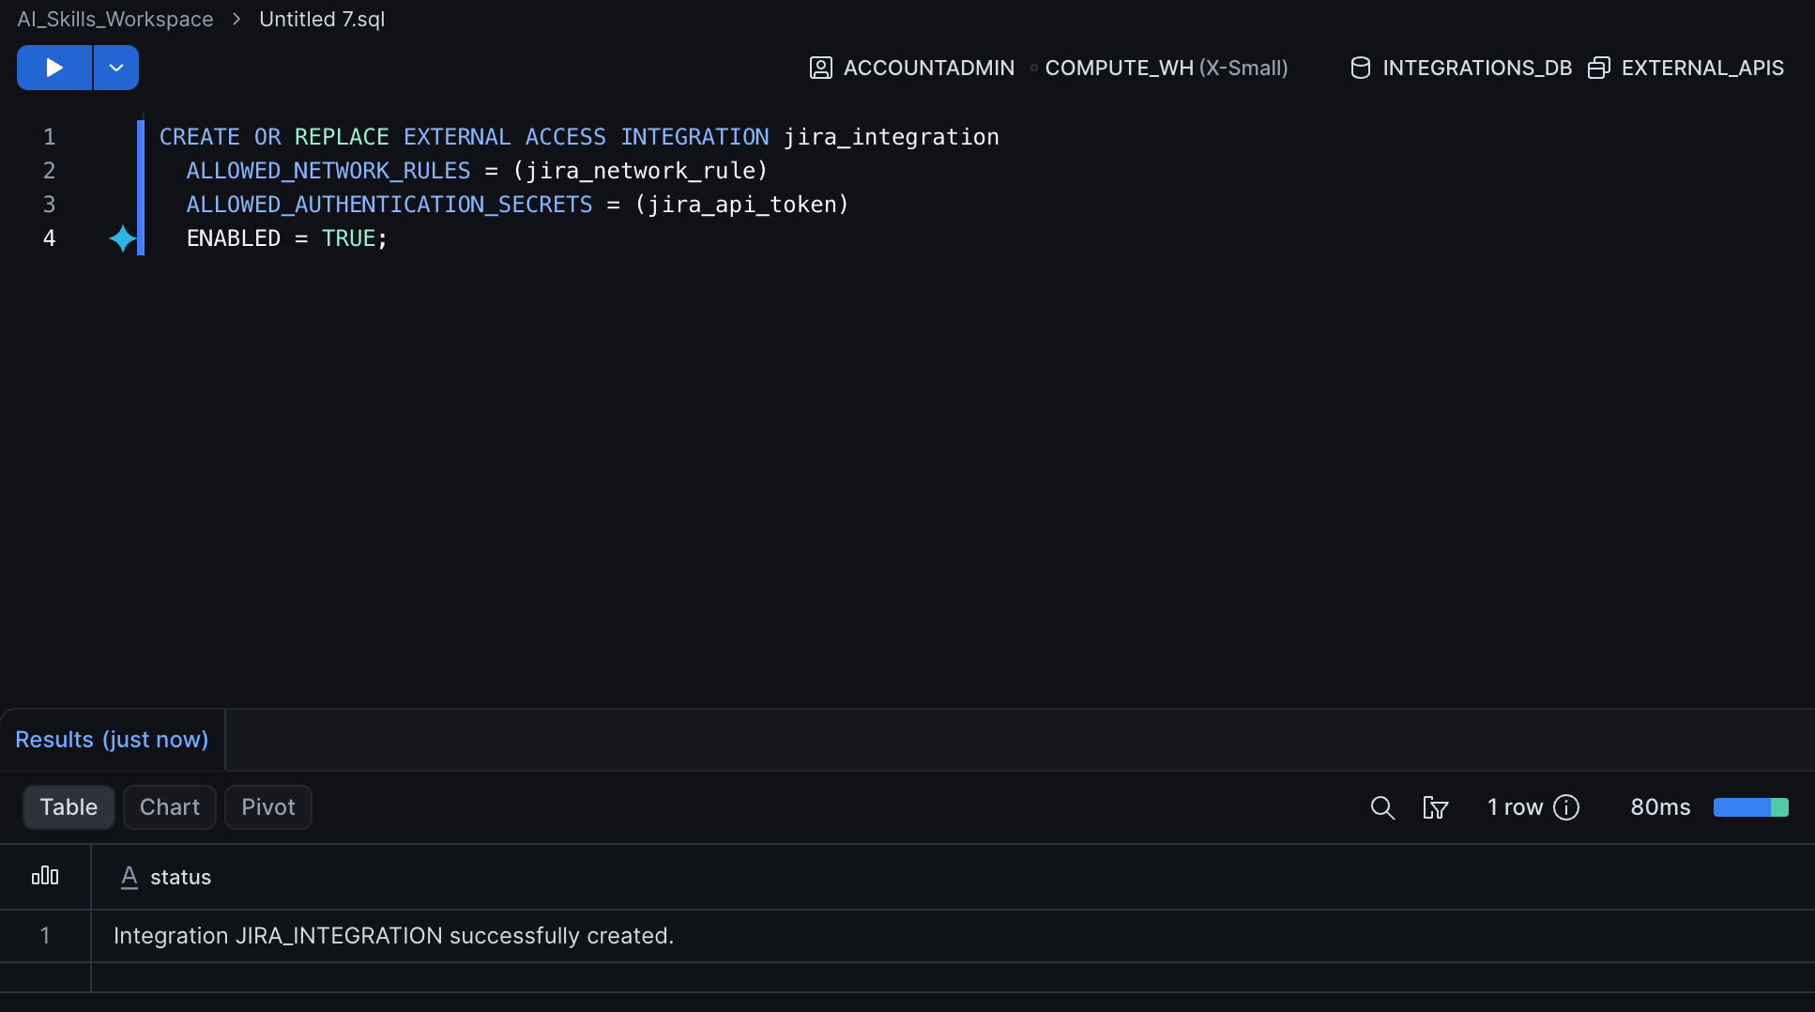
Expected Output:
Integration JIRA_INTEGRATION successfully created.

Part 2 — Creating the API Function
Now we will create a Python UDF inside Snowflake. This function takes a Jira issue key, calls the REST API, and returns the live JSON payload.

Step 1 — Define the Python UDF
Execute the following SQL block. Ensure you replace your-domain in the URL string with your actual domain.
CREATE OR REPLACE FUNCTION get_jira_issue(issue_key VARCHAR)
RETURNS VARIANT
LANGUAGE PYTHON
RUNTIME_VERSION = 3.9
HANDLER = 'get_issue'
EXTERNAL_ACCESS_INTEGRATIONS = (jira_integration)
PACKAGES = ('requests')
SECRETS = ('cred' = jira_api_token)
AS
$$
import _snowflake
import requests

def get_issue(issue_key):
credentials = _snowflake.get_username_password('cred')
url = f"https://your domain.atlassian.net/rest/api/3/issue/{issue_key}"
response = requests.get(
url,
auth=(credentials.username, credentials.password),
headers={"Accept": "application/json"}
)
if response.status_code == 200:
return response.json()
else:
return {"error": response.status_code, "message": response.text}
$$;
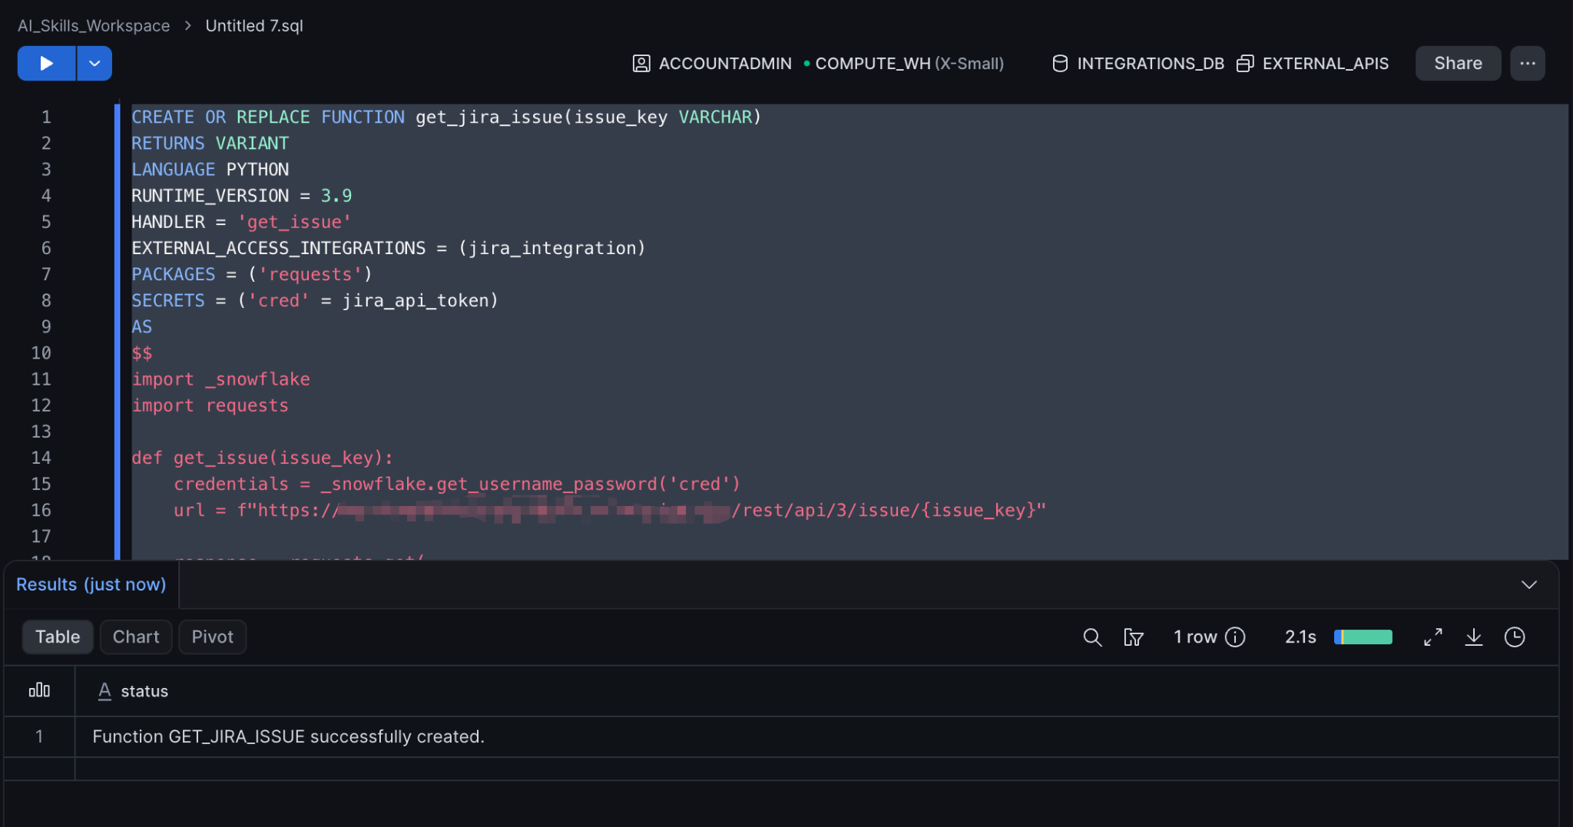
Expected Output:
Function GET_JIRA_ISSUE successfully created.

Step 2 — Test the Function Manually
Before exposing this to cortex, verify it works. Run the following SQL, replacing TEST-1 with a real ticket ID from your Jira trial.
SELECT get_jira_issue('TEST-1');
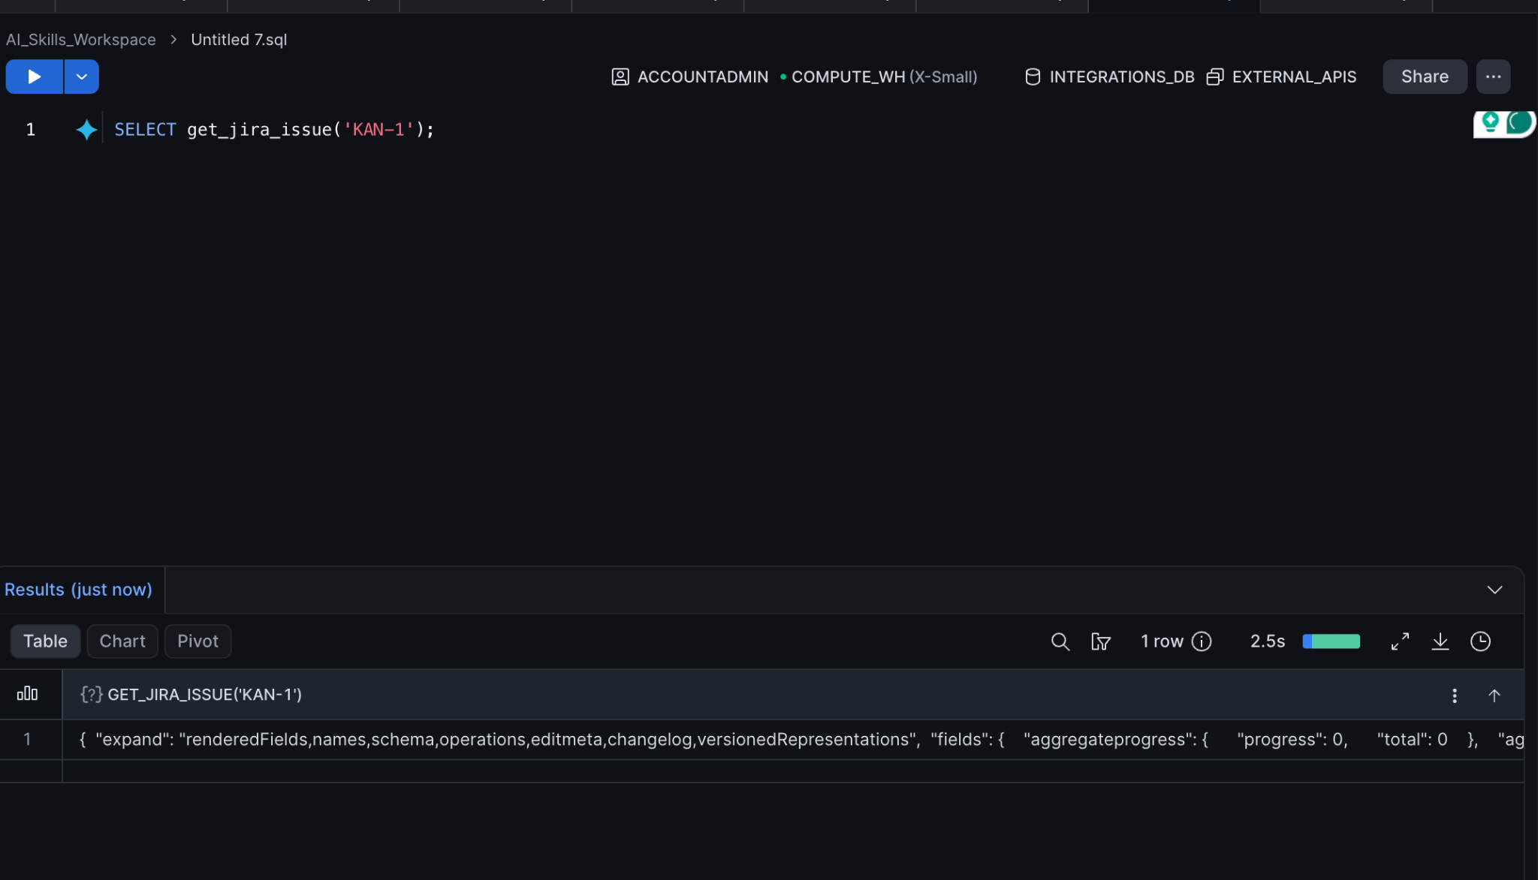
Expected Output: (A large JSON payload representing the Jira ticket data).

Part 3 — Authoring the Jira Agent Skill
We must teach cortex how to use this new capability. We will write a skill specification instructing it to invoke our UDF when asked about engineering tasks.

Step 1 — Create the Skill File Locally
Open your local terminal, create a directory, and write the skill file.
mkdir jira-integration-skill
cd jira-integration-skill
nano skill.md

Step 2 — Define the Guidelines
Paste the following specification. We explicitly instruct the agent on how to parse the complex
JSON returned by Jira.
# Jira Integration Skill
## Overview
You are an expert Engineering Project Manager. You assist developers by fetching real-time status updates for Jira issues directly from Snowflake.
## Guidelines
* **Data Source:** To retrieve Jira ticket information, you MUST generate and execute a query using the custom function `INTEGRATIONS_DB.EXTERNAL_APIS.get_jira_issue('<ISSUE_KEY>')`.
* **JSON Parsing:** The function returns a raw JSON payload. You must extract the ticket summary using `fields.summary` and the ticket status using `fields.status.name`.
* **Behavior:** When a user asks about a ticket, execute the query, read the result, and present the user with a clean, human-readable summary of the ticket's current status.
## Example Prompts
* "What is the status of ticket PROJ-42?"
* "Can you check Jira for issue DEV-99?"

(Save the file and exit your editor).

Part 4 — Deploying and Testing the Jira Integration Skill
With the skill definition completed, we can now publish it to Snowflake and verify that it can retrieve live Jira ticket information.

Step 1 — Create a Snowflake Stage
Create a stage to store the skill package.
CREATE STAGE JIRA_SKILL_STAGE;

Verify the stage:
SHOW STAGES;

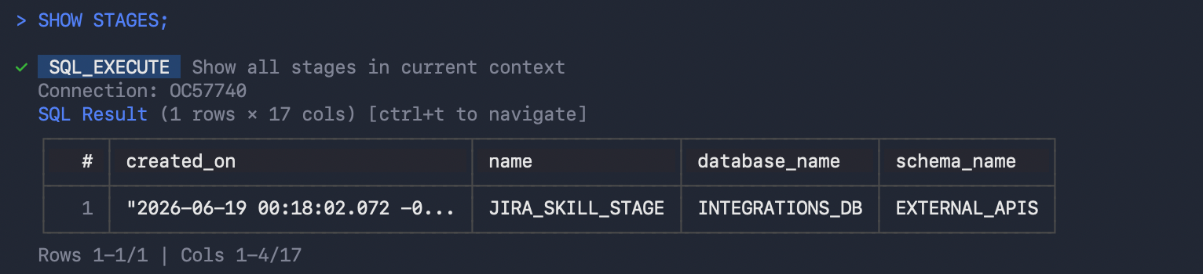

Expected Output
+------------------+
| JIRA_SKILL_STAGE |
+------------------+

Step 2 — Publish the Skill
Publish the skill to Snowflake using the stage created above.
cortex skill publish . --to-stage @JIRA_SKILL_STAGE

Expected Output
Validating skill... [OK]
Packaging skill... [OK]
Uploading to Snowflake stage... [OK]
Skill successfully published.

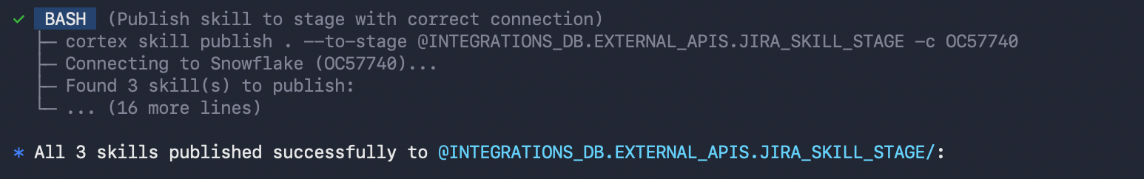

Step 3 — Register the Skill Locally
Add the skill to your local Cortex Code environment.
cortex skill add .

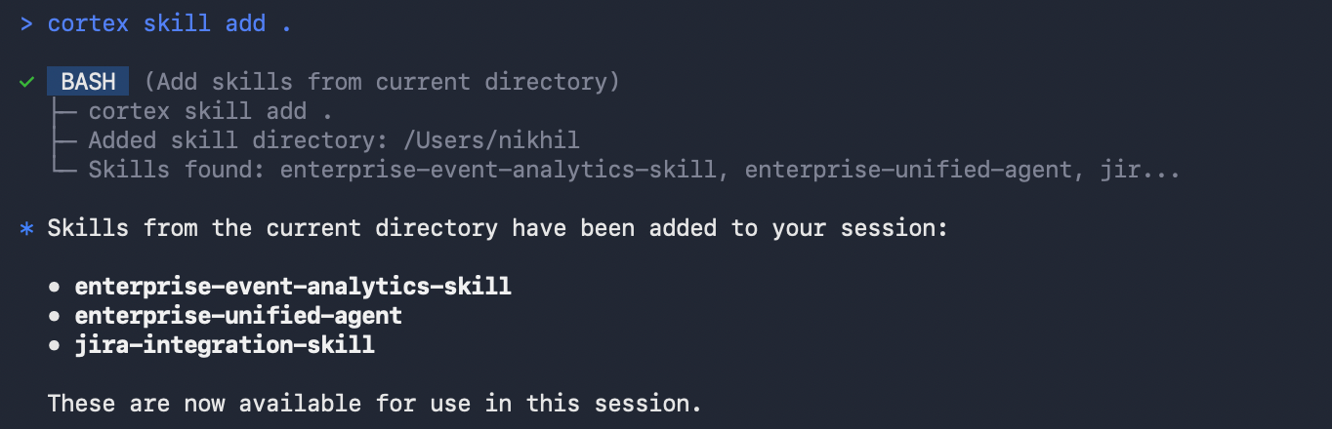

Expected Output
Added skill directory: /Users/<username>/jira-integration-skill
Skills found: jira-integration-skill

Step 4 — Start a Cortex Chat Session
Launch Cortex Code:
cortex

Expected Output
Starting interactive Cortex Code session...
Type 'exit' to quit.

>

Step 5 — Test the Jira Integration
Enter the following prompt:
What is the current status of ticket TEST-1?

Expected Output
I will check the current status of Jira ticket TEST-1.

Ticket TEST-1 ("Update authentication middleware")
is currently in the "In Progress" status.

If skill not found:
Exit Cortex:

exit
Then from your terminal:
cd ~/jira-integration-skill
cortex skill add .
cortex

And try again.

Verification
A successful response confirms that:
- The Jira integration is functioning correctly.
- Cortex can invoke the Jira lookup function.
- Live ticket information is retrieved from Jira.
- The skill is applying the business rules defined in skill.md.
Type exit to end the chat session.

Knowledge Check
- Why must we create an External Access Integration before the Python UDF can connect to Jira?
  - Answer: Snowflake compute environments are completely isolated. Without an explicit Network Rule and Integration, the virtual warehouse's outbound HTTP requests will be blocked by default to prevent data exfiltration.
- How does cortex know how to use the get_jira_issue function?
  - Answer: We explicitly defined the function signature and the required JSON parsing logic (like extracting fields.summary) inside the declarative skill.md file.

Clean Up
To prevent unauthorized outbound requests and clean up credentials, run the following tear-down commands in your SQL worksheet.
USE ROLE ACCOUNTADMIN;
DROP DATABASE IF EXISTS integrations_db;
DROP EXTERNAL ACCESS INTEGRATION IF EXISTS jira_integration;
DROP SECRET IF EXISTS jira_api_token;
DROP NETWORK RULE IF EXISTS jira_network_rule;

Troubleshooting

Symptom: {"error": 401, "message": "Unauthorized"}
Solution: A 401 error means your Jira API token is invalid, or the email address associated with the account is incorrect. Generate a new API token in Jira and recreate the jira_api_token secret in Snowflake.

Symptom: External network access is disabled
Solution: Ensure you included EXTERNAL_ACCESS_INTEGRATIONS = (jira_integration) in the CREATE FUNCTION definition and that the integration has ENABLED = TRUE.

Conclusion
In this lab, you successfully bridged the gap between your data platform and your external engineering systems. By configuring Snowflake External Network Access and authoring a custom Python UDF, you securely integrated with the Jira REST API. By wrapping this capability in a declarative cortex skill, you empowered your AI agent to fetch real-time operational data, drastically expanding its utility for product and development teams.

